Roll No:412084

Prn No:2019033800126574

Name: Yagnik Prakashbhai Mojidra

Subject: Dot Net Technologies

**Assignment-1**

**Step:1:Intro::**

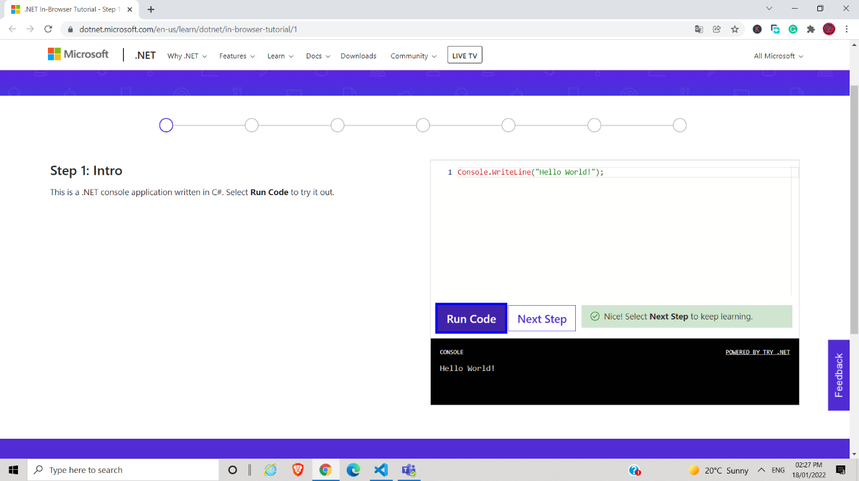

Output:

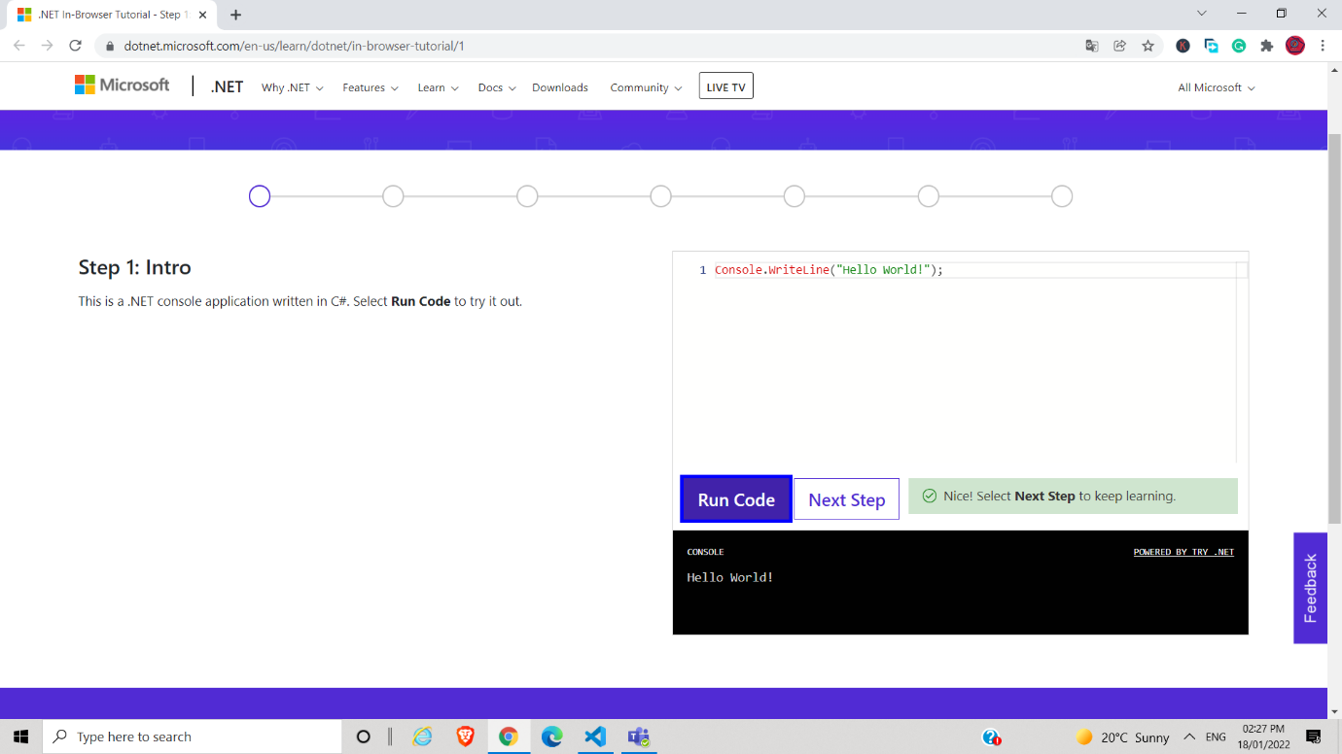

**Step:2:Strings::**

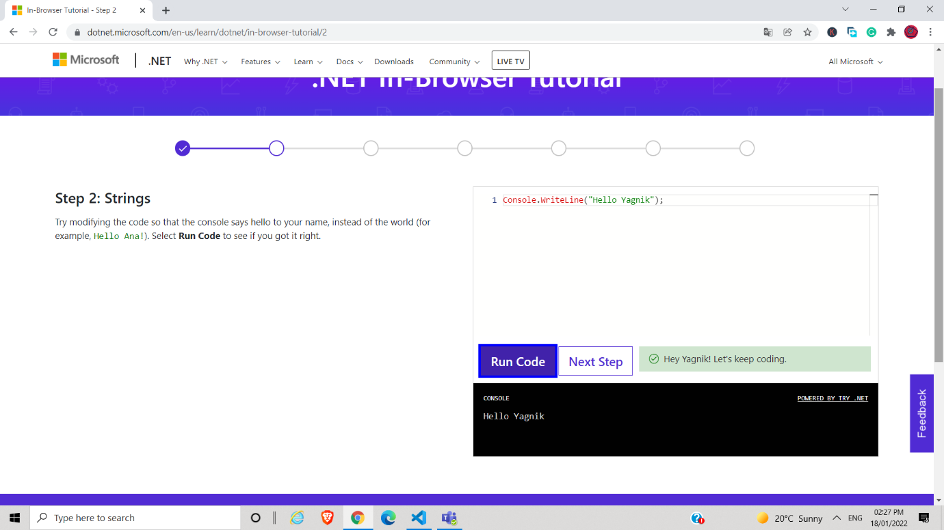

Output:

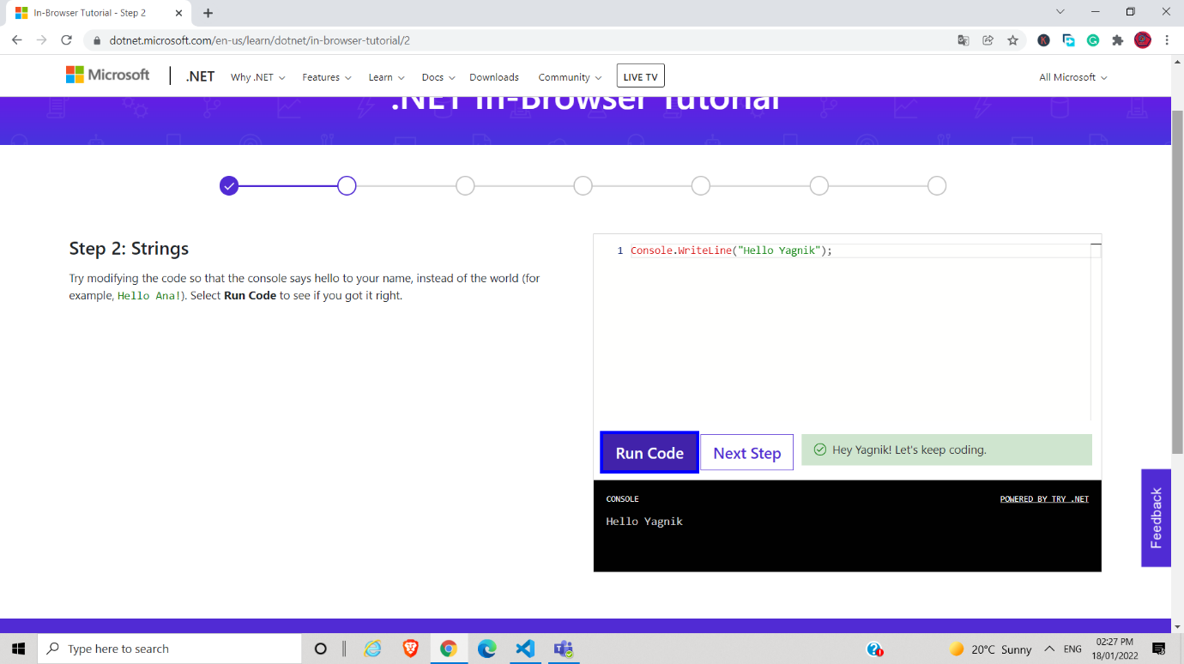

**Step:3:Variables::**

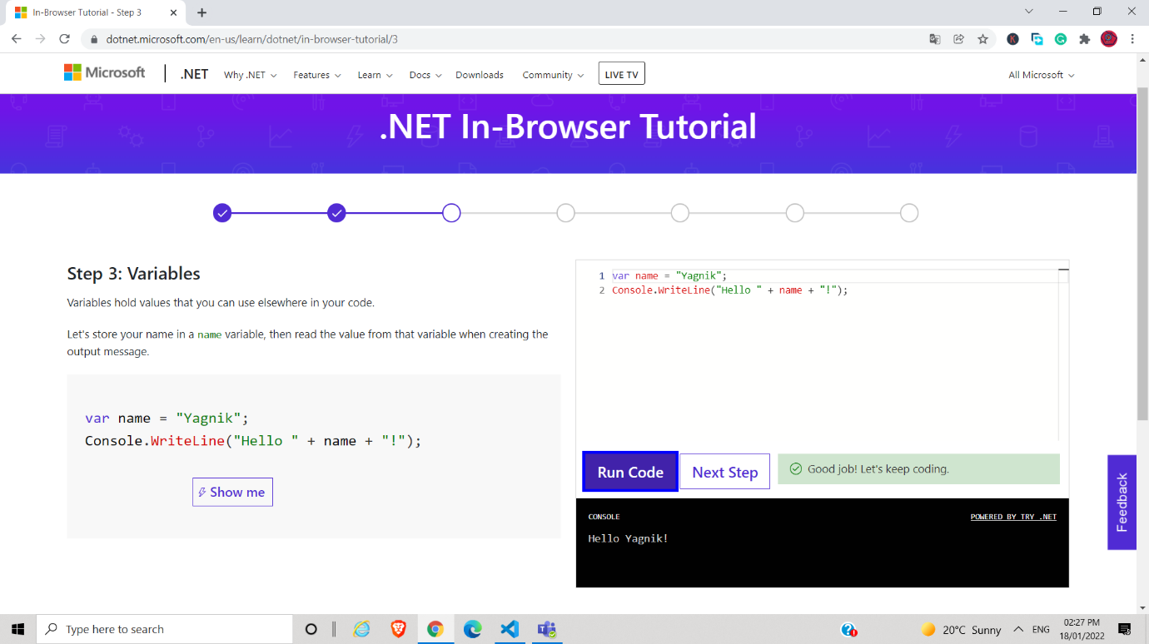

Output:



**Step:4:String Interpolation::**

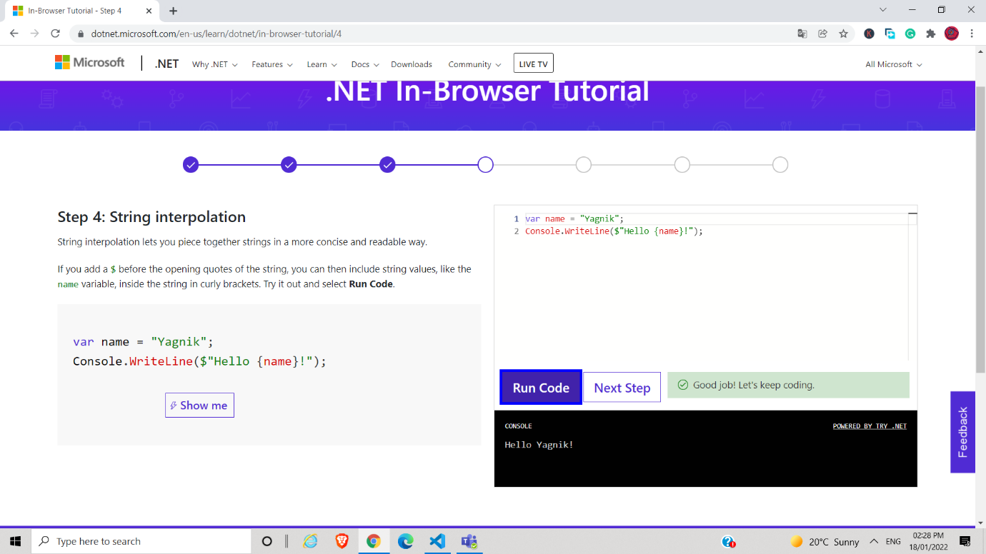

Output:

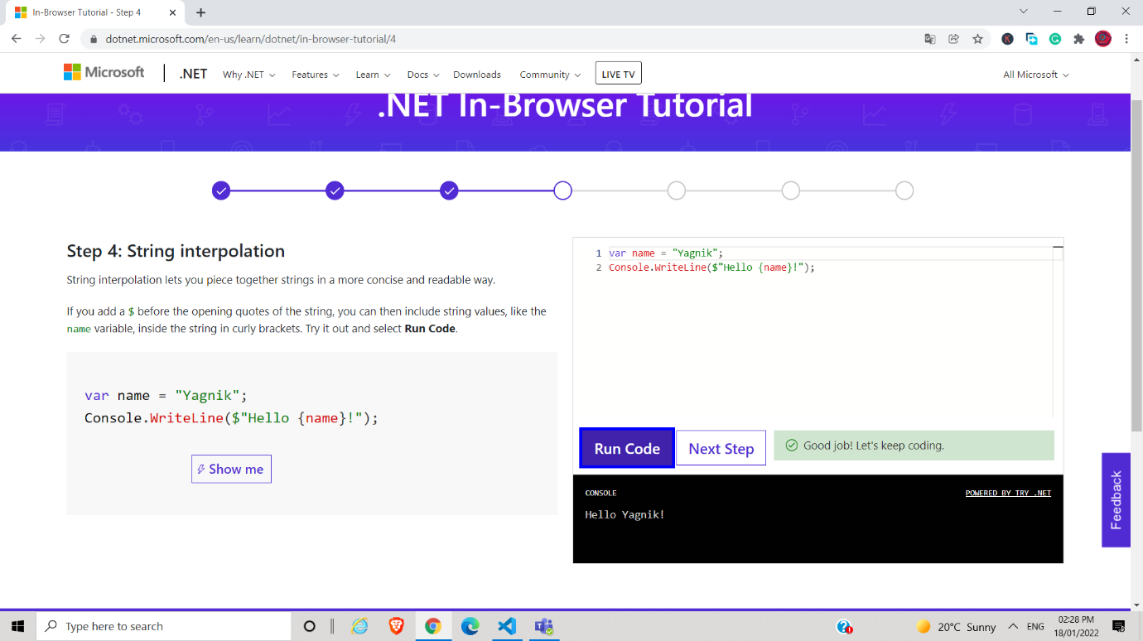

**Step:5:Methods::**

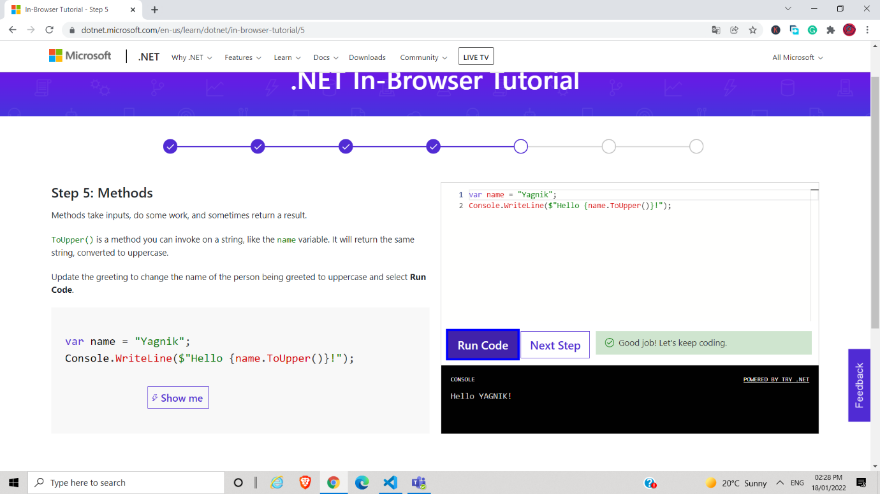

Output:

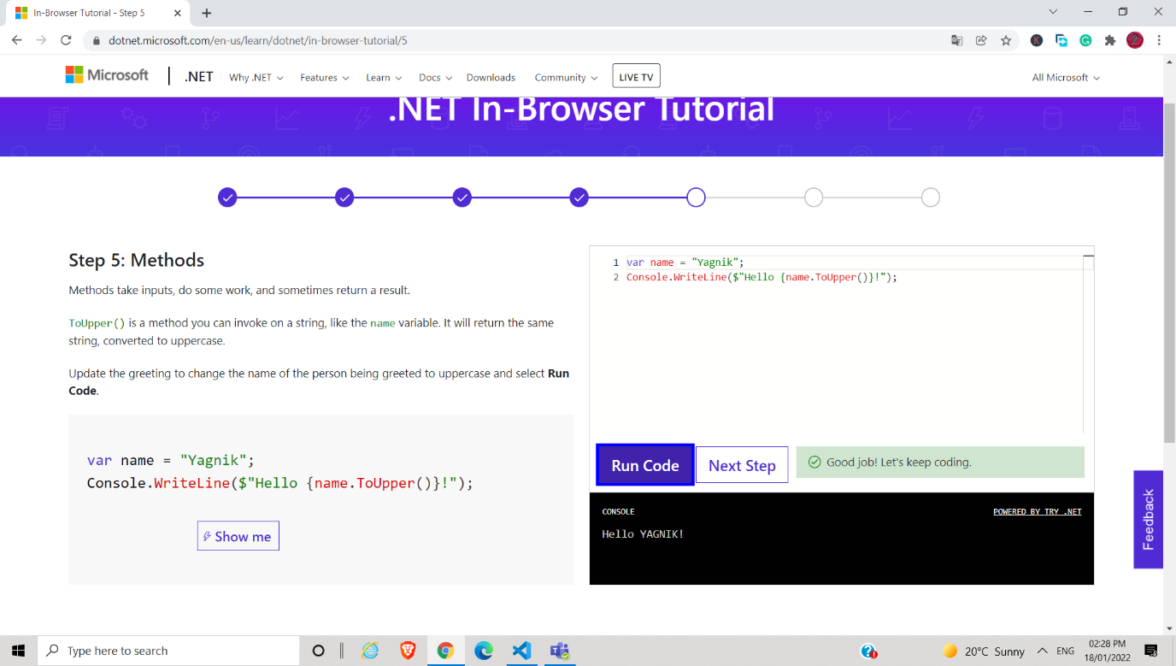

**Step:6:Collections::**

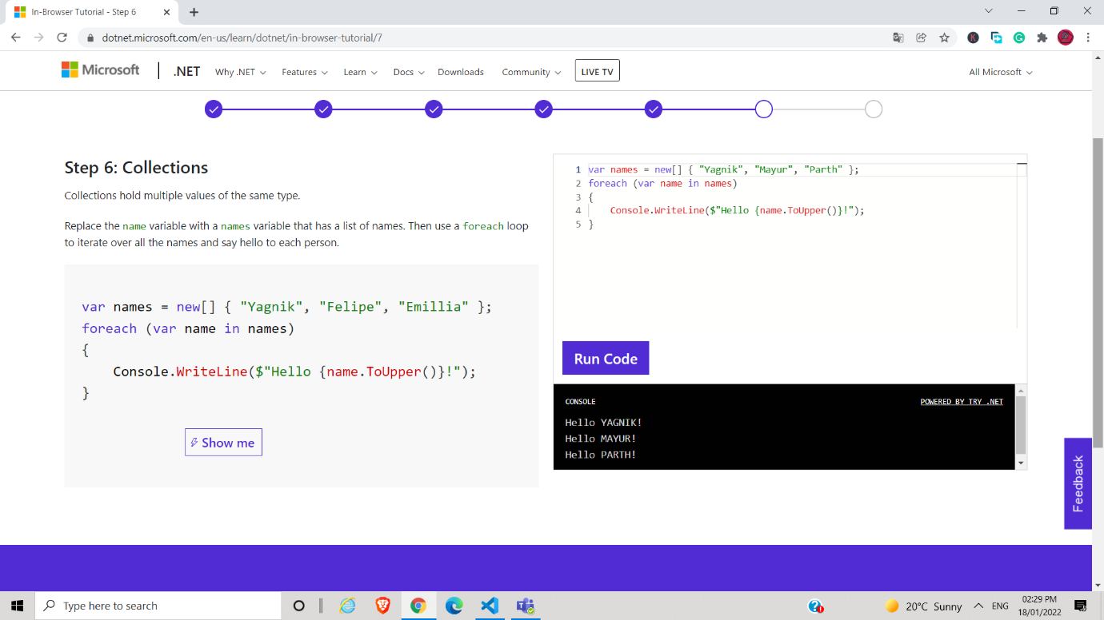

Output:

